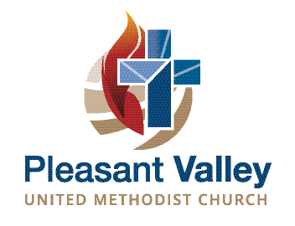
Wedding Guidelines
Adopted October 2017

We are honored that you are considering Pleasant Valley United Methodist Church for your wedding. Here is some information that you will find helpful in planning. One of our wedding coordinators would be happy to speak with you and give you a tour of our facility. To schedule, please contact the church office at 972-412-9003 or office@pvumchurch.org.

Guidelines
Officiant: Only the pastor of Pleasant Valley UMC may officiate at weddings in this church. The pastor must approve the order of service, scriptures, music selections and all bulletins prior to being printed.
Pre-wedding Consultation: The bride and groom are responsible for scheduling a pre-wedding counseling session with the pastor at least two weeks prior to the service
Deposit: A refundable security/cleaning deposit of $200 is required to reserve your date on the church calendar. This will be refunded within 10 days after the service if the sanctuary and furnishings are undamaged and restored to worship service condition.
Music: The pastor must approve all music selections. You may provide your own pianist, if desired, and the pianist fee ($150) will be waived. Our wedding coordinator can arrange for a vocal soloist, if desired (additional fee of $100). We require that one of our approved sound technicians operate the sound system.
Rental Fees: $750 includes:
- Building fee
- Minister
- Pianist
- Sound technician
- Wedding coordinator
- A wedding rehearsal not to exceed one hour the day before the ceremony
- One counseling session with the pastor
For very small weddings with no microphone or sound needs, the sound technician fee ($100) may be waived. Members of the congregation are not charged a building fee ($200).
All fees must be paid in full at least two weeks prior to the wedding and are non-refundable.
Wedding Coordinator: One of our wedding coordinators will work with you to see that your rehearsal and ceremony run smoothly. She will explain policies regarding set up and decorations and help you coordinate with florists and any other outside vendors.

Capacity: The sanctuary can seat a maximum of 76 for a wedding ceremony. We do not have facilities for an onsite reception.

